Bell Jar Manual

Vacuum Chamber User’s and Safety Manual

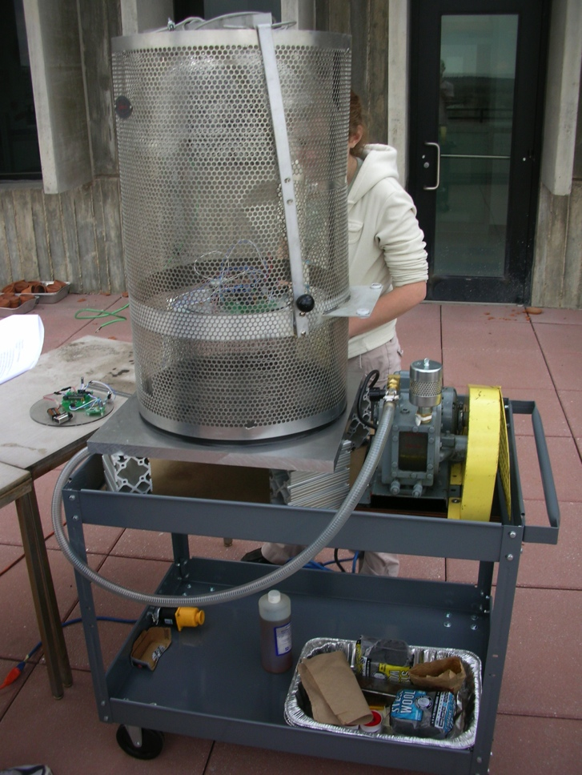

**Table of Contents**

1.0 Contact Information 2

2.0 Performance Specifications 2

3.0 Safety Precautions 4

4.0 Parts and Setup 7

5.0 Supplies 8

6.0 Operation 8

7.0 Testing Mode 12

8.0 Shutdown Procedure 13

9.0 Procedure Summary 14

10.0 Maintenance 14

Appendix A: Pressure Conversions 16

# 1.0 Contact Information

Isaac Hayden haydenisisaac@gmail.com

# 2.0 Performance Specifications

|  |  |
| --- | --- |
| **Dimensions of vacuum chamber** |  |
| **Inner Diameter (Radius)** | 17 in. (8.5 in) |
| **Height of cylinder portion** | 22 in. |
| **Total height of cylinder and half-spherical portion** | 30 in. |
| **Volume of cylinder** | 4993.56 in3 |
| **Volume of half-spherical** | 1286.22 in3 |
| **Total Volume** | 6279.78 in3 |
| **Dimensions of Stand** |  |
| **Length** | 8.625 in. |
| **Height** | 9 in. |
| **Volume** | 669.52 in3 |
| **Useable Volume** | 5610.26 in3 |
| **Data Plug Signal Specification** |  |
| **Conductors** | **15** |
| **Current per conductor** | **500 mA** |
|  |  |

|  |  |
| --- | --- |
| E:\DCIM\117___06\IMG_0809.JPG |  |
| **Oil Type** | Kinney Type AX Oil |
| **Ideal volume of oil in pump** | 120 mL |
| **Time to achieve minimum pressure** | 60 min. |
| **Pump manufacturer** | Kinney |
| **Pump type** | KC-2 High Vacuum Pump |
| E:\DCIM\117___06\IMG_0811.JPG |  |
| **Oil Type** | Mineral Oil |
| **Ideal volume of oil in pump** |  |
| **Time to achieve minimum pressure** | 1.5 hours |
| **Pump manufacturer** | PFEIRRER |
| **Pump type** |  |

# 3.0 Safety Precautions

### A. Oil level

1. The oil level needs to be between .75-1 inches below the “Add Line” on the motor.

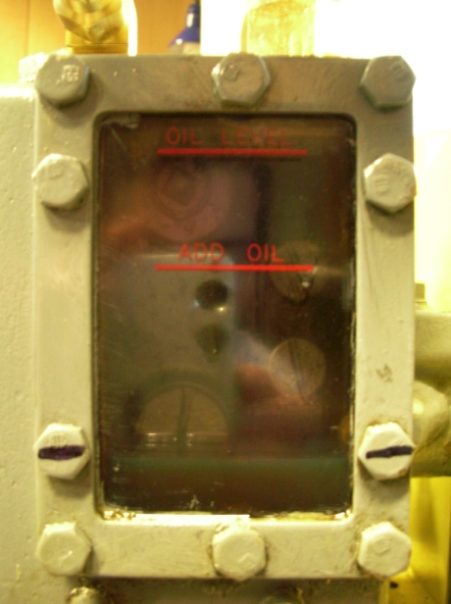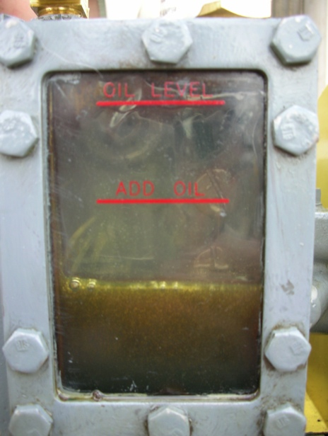

Figure 1 Oil level while not running and running

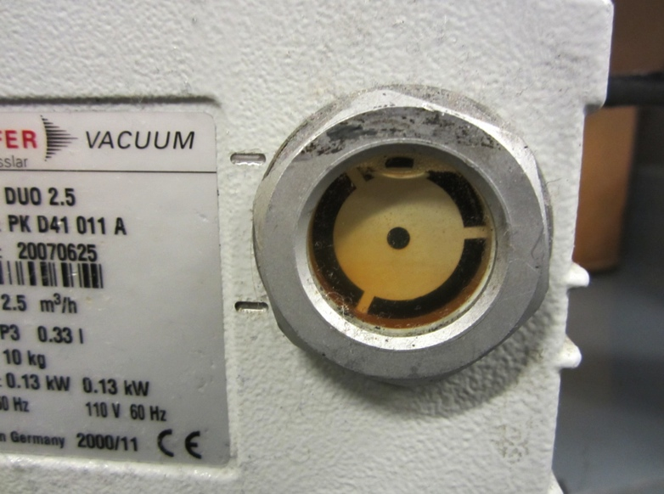

Figure 2 Oil Levels in Duo pump

# 4.0 Parts and Set up

### - Component Locations

### IMG_0819

Bell Jar

Base Plate

Pressure Release Valve

Low pressure meter

High pressure meter

Low pressure pump

High volume pump

### - Hose Arrangement

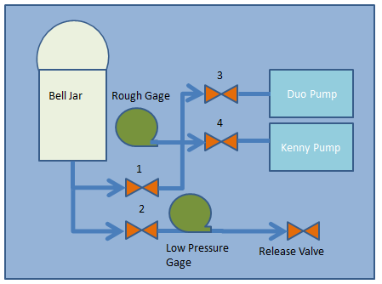

### - Release Valve location

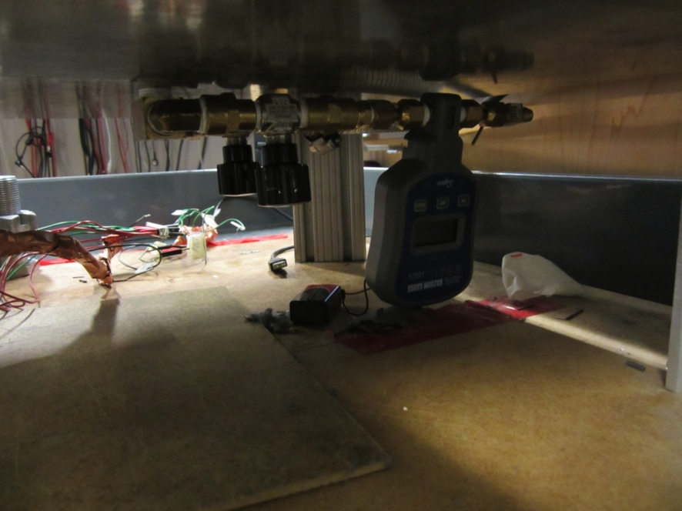

Release Valve

Valve 1

Valve 2

Low pressure Gage

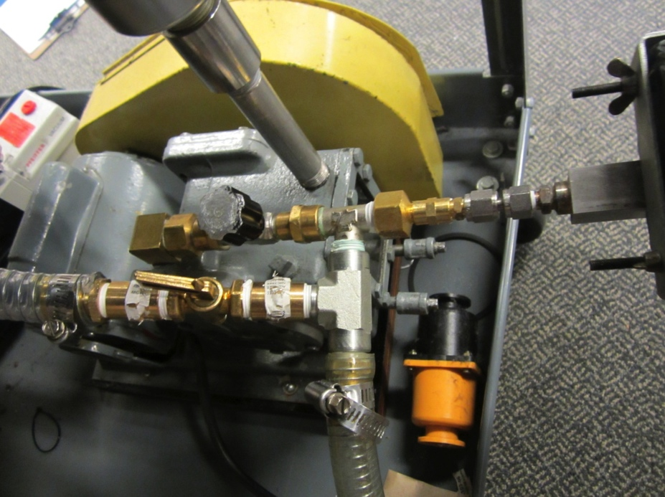

Low pressure Gage

Valve 4 (to Kinney pump)

Valve 3 (to Duo pump)

# 5.0 Supplies

- Oil Rag(s) or Paper Towels

- Oil Rag Jar (If rag used)

- Latex Gloves (at users’ discretion)

- Oil

- Steel Wool

- Polish Sand Paper

Note: most, if not all, of these supplies should be stored on the bottom level of the cart where the Bell Jar has been placed

# 6.0 Operational Guidelines (PLEASE READ)

1. Winch operation
   1. DO NOT ALLOW THE JAR TO SWING INTO THE DATA CONNECTION ON THE PLATE. This can crack the Jar and it is very expensive to fix.
   2. The witch is positioned to lift the Bell Jar only when the Bell Jar and Cart are positioned in the corner directly under the winch. The card should be flush on the counter and the back wall, with the vertical bars in the back along the wall.
   3. Keep the cable tight at all time; when the Bell Jar is on the plate do the cables should still be tight enough so that the Jar can’t be un-hooked.
   4. When lowering and raising the Bell Jar keep one hand on the Jar to prevent swinging and to help lower the Jar evenly.
   5. Do not raise the Bell Jar off the vertical poles.
2. Preparing the plate and seals
   1. In order to get best results it is necessary to clean and prep the baseplate. This allows the bell jar to get a good seal on the plate
      1. The first step is to polish the plate with steel wool. It is only necessary to polish the area where the Bell Jar is in contact with the plate.
      2. This polishing is to remove any bumps and debris on the plate
   2. Prepping the seal. The seal around the bottom of the Bell Jar should be prepped in two ways
      1. Take the seal off the Bell Jar use a paper towel or clean rag wet with vacuum fluid to wet the inside of the seal.
      2. Use the same rag and more vacuum fluid to wipe down baseplate. Again it is only necessary to coat the baseplate where the seal on the Bell Jar contacts the baseplate.
3. Checking valve positions for preparation
   1. Valve check (reverence the image below). For normal operation.
      1. The black handled valves are open when they are unscrewed outward, and the lever is open when the arm is parralle to the pipe it is attached to.



|  |  |
| --- | --- |
| Valve 1 | Open |
| Valve 2 | Open |
| Valve 3 | Open |
| Valve 4 | Open (will be closed) |
| Release Valve | Closed |

# 7.0 Testing Procedure

WEAR SAFETY GLASSES WHENEVER PUMP IS RUNNING ***AND*** WHEN SYSTEM IS PRESSURIZED.

1. READ OPERATIONAL GUIDELINES!!!!!!!!!!
2. Preform the steps necessary that are detailed in the guidelines.
3. Raise Bell Jar to required height, to allow for the test subject to be placed inside.
4. Place subject inside and if necessary plug in for electrical connections.
5. Carefully lower Bell Jar around test subject , be sure to avoid contacting the electrical connector. Lower the final 2 inches slowly to ensure that the jar seals evenly
6. Loosen the Cable on the winch, but again not enough to unhook the bell jar.
7. Ensure valves are set up in positioned shown above.
8. Turn on both pumps,
   1. The kinny should produce a glug glug sound
   2. The Duo should be a higher pitch faster wine.
9. Watch the high pressure valve until it reads about 200 mbar. At this point it will not go lower. (valve broken)
10. Turn off the Kenny pump and close valve 4. The Duo can go to a lower pressure then the Kenny and to prevent leaks it is best to take the pump out of the system.
11. Continue to monitor the low pressure gage until it has achieved desired pressure.
12. Turn off pump

# 9.0 Shutdown procedure

# 9.0 Procedure Summary:

1. Make sure all valves are closed.
2. Turn pump on, let run for 10 min.
3. Use pulley system to remove jar and place object on stand.
4. Oil plate.
5. Place jar back on plate.
6. Open valve 1 slowly.
7. Wait tell pressure is equalized in tube.
8. Open valve 2 slowly.
9. Watch filter, make sure there is no oil mist.
10. Wait until desired pressure is achieved.
11. When done, close valve 2.
12. Close valve 1.
13. Unplug pump.
14. Slowly open valve 3.
15. When no air is coming out of valve 3, safely remove jar with pulley system.

# 10.0 Maintenance

### A. Gasket and Bell Jar Maintenance

1. Keep gasket and Jar clean

2. Avoid any scuffing or marring of either the glass chamber or the rubber gasket.

### B. Plate Maintenance

1. Avoid scratching or excessive abrasion

2. In the event of large cuts or scrapes within the footprint of the gasket, disconnect or cover plate interface. Use the steel wool and sand paper to remove any abrasion as cleanly as possible. Then polish the plate’s surface.

### C. Oil level

See “I. Safety Precautions” for specifics on the oil level maintenance.

a. Make sure the pump is off.

b. To drain the oil from the pump by removing both of the bolts in the picture below:

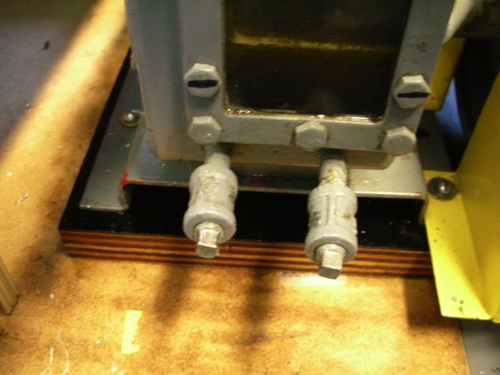

**Figure 3.3 – Bolts for draining of the oil**

c. Be sure to have something for the oil to drain into because as soon as you remove these bolts, OIL WILL COME OUT.

d. To remove ALL oil the pump will have to be tipped to get the oil to flow to the bolts from within the motor.

e. Once all of the oil has been drained (no more is coming out), then put the bolts back in place in order to proceed to the next step.

4. Remove the oil mist eliminator:

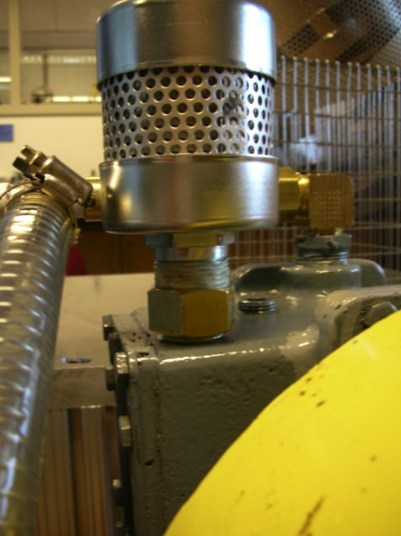

**Figure 3.4 – Oil Mist Filter**

a. Remove the filter by using a wrench on the attachment closest to the pump to loosen and then take off the oil mist filter and fitting.

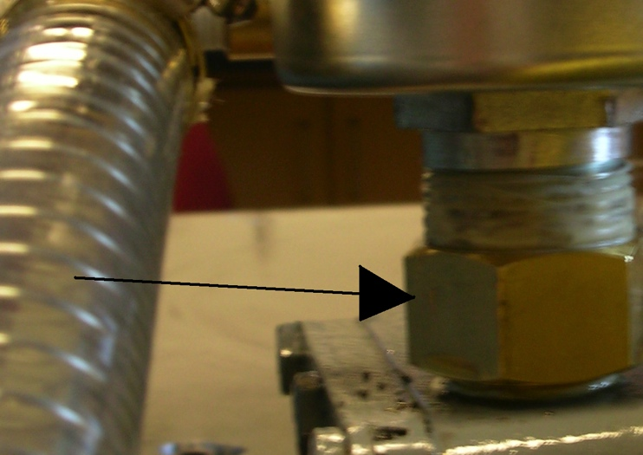

**Figure 3.5 – The arrow points to the attachment**

**that should be used to take off the filter**

4. Add the necessary amount of oil using the funnel at an angle to the hole.

5. Replace filter using sealing tape– TIGHTLY, AND PLENTY OF IT, OR ELSE OIL AND FUMES WILL COME OUT.

B. Safety cage

1. NEVER remove the safety cage around the vacuum jar. It is there for a reason.

Appendix A: Pressure Conversions

|  |  |  |  |  |  |  |
| --- | --- | --- | --- | --- | --- | --- |
| **Pressure Units** | | | | | | |
|  | [**Pascal**](http://en.wikipedia.org/wiki/Pascal_%28unit%29) **(Pa)** | [**Bar**](http://en.wikipedia.org/wiki/Bar_%28unit%29) **(bar)** | [**Technical atmosphere**](http://en.wikipedia.org/wiki/Technical_atmosphere) **(at)** | [**Atmosphere**](http://en.wikipedia.org/wiki/Atmosphere_%28unit%29) **(atm)** | [**Torr**](http://en.wikipedia.org/wiki/Torr) **(mmHg)** | [**Pound-force per square inch**](http://en.wikipedia.org/wiki/Pound-force_per_square_inch) **(psi)** |
| **1 Pa** | ≡ 1 N/m² | 10−5 | 10.197×10−6 | 9.8692×10−6 | 7.5006×10−3 | 145.04×10−6 |
| **1 bar** | 100 000 | ≡ 106 dyn/cm² | 1.0197 | 0.98692 | 750.06 | 14.504 |
| **1 at** | 98 066.5 | 0.980665 | ≡ 1 kgf/cm² | 0.96784 | 735.56 | 14.223 |
| **1 atm** | 101 325 | 1.01325 | 1.0332 | ≡ 1 [atm](http://en.wikipedia.org/wiki/Atmosphere_%28unit%29) | 760 | 14.696 |
| **1 torr** | 133.322 | 1.3332×10−3 | 1.3595×10−3 | 1.3158×10−3 | ≡ 1 mmHg | 19.337×10−3 |
| **1 psi** | 6 894.76 | 68.948×10−3 | 70.307×10−3 | 68.046×10−3 | 51.715 | ≡ 1 lbf/in² |

**Example reading:** 1 Pa = 1 N/m² = 10−5 bar = 10.197×10−6 at = 9.8692×10−6 atm ....etc.

## Altitude atmospheric pressure variation

|  |  |  |
| --- | --- | --- |
| **fraction of 1 atm** | **average altitude** | |
| **(m)** | **(ft)** |
| 1 | 0 | 0 |
| 1/2 | 5,486.3 | 18,000 |
| 1/3 | 8,375.8 | 27,480 |
| 1/10 | 16,131.9 | 52,926 |
| 1/100 | 30,900.9 | 101,381 |
| 1/1000 | 48,467.2 | 159,013 |
| 1/10000 | 69,463.6 | 227,899 |
| 1/100000 | 96,281.6 | 283,076 |

## 

## Calculating variation with altitude

Equation 1:

{P}=P_b \cdot \left[\frac{T_b}{T_b + L_b\cdot(h-h_b)}\right]^\frac{g_0 \cdot M}{R^* \cdot L_b}

Equation 2:

{P}=P_b \cdot \exp \left[\frac{-g_0 \cdot M \cdot (h-h_b)}{R^* \cdot T_b}\right]

where

*P* = Static pressure (pascals)

*T* = Standard temperature (kelvins)

*L* = Standard temperature lapse rate (kelvins per meter)

*h* = Height above sea level (meters)

*R* \* = Universal gas constant for air: 8.31432×103 N·m / (kmol·K)

*g*0 = Gravitational constant (9.80665 m/s²)

*M* = Molar mass of Earth's air (28.9644 g/mol)

Or converted to English units:

where

*P* = Static pressure (inches of mercury)

*T* = Standard temperature (kelvins)

*L* = Standard temperature lapse rate (kelvins per foot)

*h* = Height above sea level (feet)

*R* \* = Universal gas constant (using feet and kelvins and gram moles: 8.9494596×104 kg·ft2·s-2·K-1·kmol-1)

*g*0 = Gravitational constant (32.17405 ft/s²)

*M* = Molar mass of Earth's air (28.9644 g/mol)

|  |  |  |  |  |  |  |  |
| --- | --- | --- | --- | --- | --- | --- | --- |
| **Subscript *b*** | **Height Above Sea Level** | | **Static Pressure** | | **Standard Temperature (K)** | **Temperature Lapse Rate** | |
| **(m)** | **(ft)** | **(pascals)** | **(inHg)** | **(K/m)** | **(K/ft)** |
| 0 | 0 | 0 | 101325 | 29.92126 | 288.15 | -0.0065 | -0.0019812 |
| 1 | 11,000 | 36,089 | 22632.1 | 6.683245 | 216.65 | 0.0 | 0.0 |
| 2 | 20,000 | 65,617 | 5474.89 | 1.616734 | 216.65 | 0.001 | 0.0003048 |
| 3 | 32,000 | 104,987 | 868.019 | 0.2563258 | 228.65 | 0.0028 | 0.00085344 |
| 4 | 47,000 | 154,199 | 110.906 | 0.0327506 | 270.65 | 0.0 | 0.0 |
| 5 | 51,000 | 167,323 | 66.9389 | 0.01976704 | 270.65 | -0.0028 | -0.00085344 |
| 6 | 71,000 | 232,940 | 3.95642 | 0.00116833 | 214.65 | -0.002 | -0.0006096 |

Sample Calculation:

Find the pressure at 30,000 meters. First note that 30,000 meters is above 20,000 but below 32,000 so it therefore falls in the range of subscript b=2 in the chart above. Also note that the temperature lapse rate for that region is not equal to zero; therefore, equation 1 is appropriate.

{P}=P_2 \cdot \left[\frac{T_2}{T_2 + L_2\cdot(h-h_2)}\right]^\frac{g_0 \cdot M}{R^* \cdot L_2}

Or

{P}=5474.89 \cdot \left[\frac{216.65}{216.65 + 0.001\cdot(30,000-20,000)}\right]^\frac{9.80665  \cdot 28.9644}{8314.32 \cdot 0.001}

{P}=5474.89 \cdot \left[\frac{216.65}{226.65)}\right]^{34.163195}

{P}=5474.89 \cdot 0.214044

{P}\ = 1171.867 (Pascals at 30,000 meters)

**Conversion Table for Pressure**

|  |  |  |
| --- | --- | --- |
| **To convert** | **Into** | **Multiply by** |
| atmosphere | bar | 1.01295 |
| atmosphere | dynes/cm2 | 1.01295 x 106 |
| atmosphere | in. Hg | 29.9213 |
| atmosphere | in. water | 406.86 |
| atmosphere | kg/cm2 | 1.03325 |
| atmosphere | mbar | 1012.95 |
| atmosphere | mtorr or micron Hg | 7.6 x 105 |
| atmosphere | Pa or N/m2 | 1.01295 x 105 |
| atmosphere | PSI or lb/in2 | 14.696 |
| atmosphere | torr or mm Hg | 760 |
| bar | atmosphere | 0.9872 |
| bar | dynes/cm2 | 1 x 106 |
| bar | in. Hg | 29.54 |
| bar | in. water | 401.65 |
| bar | kg/cm2 | 1.02 |
| bar | mbar | 1000 |
| bar | mtorr or micron Hg | 7.5028 x 105 |
| bar | Pa or N/m2 | 1 x 105 |
| bar | psi or lb/in2 | 14.503861 |
| bar | torr or mm Hg | 750.2838 |
| dynes/cm2 | atmosphere | 9.872 x 10-7 |
| dynes/cm2 | bar | 1 x 10-6 |
| dynes/cm2 | in. Hg | 2.954 x 10-5 |
| dynes/cm2 | in. water | 4.0165 x 10-4 |
| dynes/cm2 | kg/cm2 | 1.0200 x 10-6 |
| dynes/cm2 | mbar | 1 x 10-3 |
| dynes/cm2 | mtorr or micron Hg | 0.75028 |
| dynes/cm2 | Pa or N/m2 | 0.1 |
| dynes/cm2 | psi or lb/in2 | 1.4508 x 10-5 |
| dynes/cm2 | torr or mm Hg | 7.5028 x 10-4 |
| in. Hg | atmosphere | 3.342 x 10-2 |
| in. Hg | bar | 3.385 x 10-2 |
| in. Hg | dynes/cm2 | 3.385 x 104 |
| in. Hg | in. water | 13.598 |
| in. Hg | kg/cm2 | 3.4532 x 10-2 |
| in. Hg | mbar | 33.85 |
| in. Hg | mtorr or micron Hg | 2.54 x 104 |
| in. Hg | Pa or N/m2 | 3385 |
| in. Hg | psi or lb/in2 | 0.4912 |
| in. Hg | torr or mm Hg | 25.4 |
| in. water | atmosphere | 2.458 x 10-3 |
| in. water | bar | 2.489 x 10-3 |
| in. water | dynes/cm2 | 2.489 x 103 |
| in. water | kg/cm2 | 2.5396 x 10-3 |
| in. water | in. Hg | 7.354 x 10-2 |
| in. water | mbar | 2.489 |
| in. water | mtorr or micron Hg | 1.868 x 10-3 |
| in. water | Pa or N/m2 | 248.9 |
| in. water | psi or lb/in2 | 3.612 x 10-2 |
| in. water | torr or mm Hg | 1.868 |
| kg/cm2 | atmosphere | 0.9678 |
| kg/cm2 | bar | 0.9804 |
| kg/cm2 | dynes/cm2 | 9.804 x 105 |
| kg/cm2 | in. Hg | 28.958 |
| kg/cm2 | in. water | 393.76 |
| kg/cm2 | mbar | 9.804 x 102 |
| kg/cm2 | mtorr or micron Hg | 7.3554 x 105 |
| kg/cm2 | Pa or N/m2 | 9.804 x 104 |
| kg/cm2 | psi or lb/in2 | 14.223 |
| kg/cm2 | torr or mm Hg | 7.3554 x 102 |
| mbar | atmosphere | 9.872 x 10-4 |
| mbar | bar | 0.001 |
| mbar | dynes/cm2 | 1000 |
| mbar | kg/cm2 | 1.0200 x 10-3 |
| mbar | in. Hg | 2.954 x 10-2 |
| mbar | in. water | 0.4018 |
| mbar | mtorr or micron Hg | 7.5028 x 102 |
| mbar | Pa or N/m2 | 100 |
| mbar | psi or lb/in2 | 1.450 x 10-2 |
| mbar | torr or mm Hg | 0.75028 |
| mtorr or micron Hg | atmosphere | 1.316 x 10-6 |
| mtorr or micron Hg | bar | 1.3328 x 10-6 |
| mtorr or micron Hg | dynes/cm2 | 1.3328 |
| mtorr or micron Hg | kg/cm2 | 1.3595 x 10-6 |
| mtorr or micron Hg | in. Hg | 3.937 x 10-5 |
| mtorr or micron Hg | in. water | 5.353 x 10-4 |
| mtorr or micron Hg | mbar | 1.3328 x 10-3 |
| mtorr or micron Hg | Pa or N/m2 | 0.13328 |
| mtorr or micron Hg | psi or lb/in2 | 1.934 x 10-5 |
| mtorr or micron Hg | torr or mm Hg | 1 x 10-3 |
| Pa or N/m2 | atmosphere | 9.869 x 10-6 |
| Pa or N/m2 | bar | 1 x 10-5 |
| Pa or N/m2 | dynes/cm2 | 10 |
| Pa or N/m2 | kg/cm2 | 1.020 x 10-5 |
| Pa or N/m2 | in. Hg | 2.954 x 10-4 |
| Pa or N/m2 | in. water | 4.018 x 10-3 |
| Pa or N/m2 | mbar | 0.01 |
| Pa or N/m2 | mtorr or micron Hg | 7.5028 |
| Pa or N/m2 | psi or lb/in2 | 1.4508 x 10-4 |
| Pa or N/m2 | torr or mm Hg | 7.5028 x 10-3 |
| psi or lb/in2 | atmosphere | 0.068046 |
| psi or lb/in2 | bar | 0.068948 |
| psi or lb/in2 | dynes/cm2 | 6.8948 x 104 |
| psi or lb/in2 | kg/cm2 | 7.0309 x 10-2 |
| psi or lb/in2 | in. Hg | 2.036 |
| psi or lb/in2 | in. water | 27.68 |
| psi or lb/in2 | mbar | 68.948 |
| psi or lb/in2 | mtorr or micron Hg | 5.171 x 104 |
| psi or lb/in2 | Pa or N/m2 | 6.8927 x 103 |
| psi or lb/in2 | torr or mm Hg | 51.71 |
| torr or mm Hg | atmosphere | 1.3158 x 10-3 |
| torr or mm Hg | bar | 1.3328 x 10-3 |
| torr or mm Hg | dynes/cm2 | 1.3328 x 103 |
| torr or mm Hg | kg/cm2 | 1.3595 x 10-3 |
| torr or mm Hg | in. Hg | 3.937 x 10-2 |
| torr or mm Hg | in. water | 0.5353 |
| torr or mm Hg | mbar | 1.3328 |
| torr or mm Hg | mtorr or micron Hg | 1000 |
| torr or mm Hg | Pa or N/m2 | 133.28 |
| torr or mm Hg | psi or lb/in2 | 1.934 x 10-2 |

Appendix B: Cost Analysis

|  |  |  |  |
| --- | --- | --- | --- |
| Option #1: Fix Kinney KC-2 High Vacuum Pump With Factory Parts | | | |
|  |  |  |  |
| Part | Quantity | Price Per | Total Cost |
| Vacuum Torr Gauge | 2 | $399 | $798 |
| Oil Mist Eliminator | 1 | $300 | $300 |
| Oil Mist Eliminator Element | 1 | $80 | $80 |
| Oil Mist Eliminator Gasket | 1 | $4 | $4 |
| Steel Wire Reinforced | 2 | $3.50 | $7.00 |
| High Vacuum Threaded Nipple | 1 | $6.97 | $6.97 |
| Worm-Drive Hose Clamp | 1 | $5 | $5 |
| Flared Fitting to Barbed | 1 | $12.58 | $12.58 |
| Flared to Threaded Joint | 1 | $2.83 | $4.91 |
| Kinney Type AX Oil | 3 Quarts | $10 | $30 |
| Total |  |  | $1,248.46 |

|  |  |  |  |
| --- | --- | --- | --- |
| Option #2: Fix Kinney KC-2 High Vacuum Pump With Various Cheaper Parts | | | |
|  |  |  |  |
| Part | Quantity | Price Per | Total Cost |
| Oil Mist Eliminator From Ebay | 1 | $35 | $35 |
| Supco Digital Vacuum Gauge | 1 | $165.79 | $165.79 |
| Steel Wire Reinforced Vacuum Hose | 2 | $3.50 | $7.00 |
| High Vacuum Threaded Nipple | 1 | $6.97 | $6.97 |
| Worm-Drive Hose Clamp | 1 | $5 | $5 |
| Flared Fitting to Barbed Nipple | 1 | $2.83 | $4.92 |
| Flared to Threaded Joint | 1 | $10 | $10 |
| Kinney Type AX Oil | 3 Quarts | $10 | $30.00 |
| Total |  |  | $264.68 |

|  |  |  |  |
| --- | --- | --- | --- |
| Option #3: Buy Robinair 6 CFM 2 Stage Vacuum Pump | | | |
|  |  |  |  |
| Part | Quantity | Price Per | Total Cost |
| Robinair 6 CFM 2 Stage Vacuum Pump | 1 | $300 | $300 |
| Steel Wire Reinforced Vacuum Hose | 2 | $3.50 | $7.00 |
| High Vacuum Threaded Nipple | 1 | $6.97 | $6.97 |
| Worm-Drive Hose Clamp | 1 | $5 | $5 |
| Flared Fitting to Barbed Nipple | 1 | $12.58 | $12.58 |
| Flared to Threaded Joint | 1 | $2.83 | $4.91 |
| Total |  |  | $336.46 |

|  |  |  |  |  |
| --- | --- | --- | --- | --- |
| Pump Specifications | |  |  |  |
|  |  |  |  |  |
| Option | Pump Name | Price | Vacuum | Speed |
| 1 | Kinney KC-2 High Vacuum Pump | $1,223.27 | .1-2 umHg | 2 CFM |
| 2 | Kinney KC-2 High Vacuum Pump | $242.06 | .1-2 umHg | 2 CFM |
| 3 | Robinair 6 CFM 2 Stage Vacuum Pump | $311.27 | 20 umHg | 6 CFM |